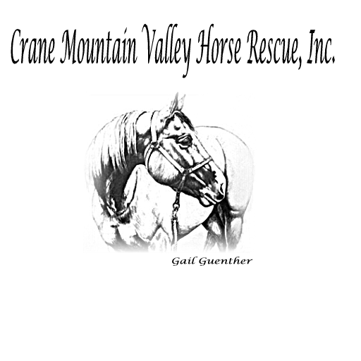

ADOPTION QUESTIONNAIRE

NAME OF HORSE: ______________________________ DATE: ___________

Name: _______________________________ Home phone: __________________

Address: _____________________________ E-mail: _______________________

City: _____________________ State: _______ Zip code: ___________

Previous Address: ________________________________________________________

Employer: ______________________________________________________________

1. Do you? Rent Own Live with parents

Landlord’s name: _______________________________ Phone: _________________

2. Will the horse be kept on your property? Yes No

If yes, with how many other horses? _____________

Describe the area and shelter provided: ________________________________________

________________________________________________________________________

________________________________________________________________________

________________________________________________________________________

If no, list the address and description of the boarding/training facility: _______________

________________________________________________________________________

________________________________________________________________________

________________________________________________________________________

Trainer/Manager: __________________________ Home phone: __________________

Facility phone: ____________________________ Hours of operation: _____________

3. Do you currently own a horse? Yes No How many? _______

If yes, please describe: ____________________________________________________

________________________________________________________________________

If no, have you previously owned a horse? Yes No

Describe briefly what happened to them: ______________________________________

________________________________________________________________________

________________________________________________________________________

4. What type of horse are you specifically interested in? Age: _____________

Breed preference: __________________________ Height: _________________

Range of training: ________________________________________________________

Other: _________________________________________________________________

Height of rider: ______________________ Weight of rider: ________________

5. Briefly describe your level of expertise in the following areas:

Riding: ________________________________________________________________

________________________________________________________________________

Handling: _______________________________________________________________

________________________________________________________________________

Training: _______________________________________________________________

________________________________________________________________________

Working with young or green / unstarted horses: ________________________________

________________________________________________________________________

6. Who will ride the adopted horse? _________________________________________

7. Which member of your household will be responsible for the feeding? ___________

________________________________________________________________________

Training: _______________________________________________________________

General care of the horse: __________________________________________________

What is their level of expertise: _____________________________________________

________________________________________________________________________

8. How often do you feel a horse should be wormed: ___________________________

Hooves trimmed: ___________________ Teeth floated: ________________

What types of vaccinations should a horse receive: _____________________________

_______________________________________________________________________

9. Why do you want to adopt a horse? ______________________________________

________________________________________________________________________

________________________________________________________________________

10. If you own an animal now, who is your:

Veterinarian: ____________________________ Phone: _______________________

Farrier: _________________________________ Phone: _______________________

If you do not currently own an animal, who will be your:

Veterinarian: ____________________________ Phone: _______________________

Farrier: _________________________________ Phone: _______________________

11. Please indicate when it would be convenient for us to do a property/barn inspection:

________________________________________________________________________

12. Please provide three references:

Name: ____________________________________

Address: __________________________________

__________________________________________

Daytime phone: ____________________________

Name: ____________________________________

Address: __________________________________

__________________________________________

Daytime phone: ____________________________

Name: ____________________________________

Address: __________________________________

__________________________________________

Daytime phone: ____________________________

13. I/We certify that all the information contained herein is true and correct.

Signature: ____________________________________ Date: __________________

Printed name: _________________________________

Signature: ____________________________________ Date: __________________

Printed name: _________________________________

7556 NYS Route 9N, Westport, New York 12993 ~ 518-962-8512 ~ horses@cmvhr.org

www.cmvhr.org

